
Title:
Task 1
Create one Jenkins job using the below code and create three stages:
- stage1: Git clone to download the source code.
URL: https://github.com/betawins/VProfile-1.git
Step by Step Implementation:
Login to Jenkins using publicip:portnumber
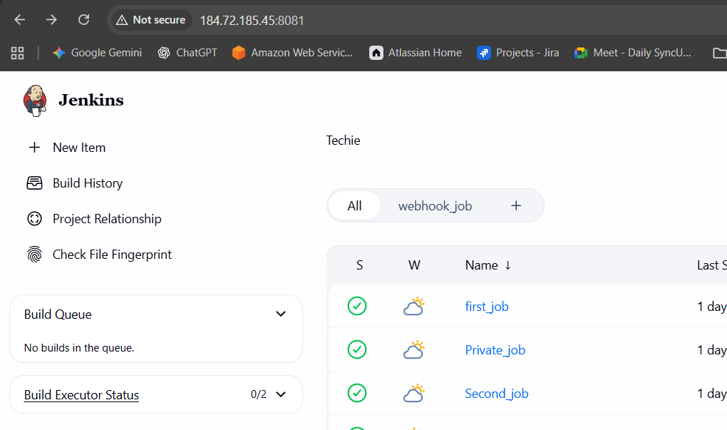

Create a Freestyle Job and Provide the name as Vprofile
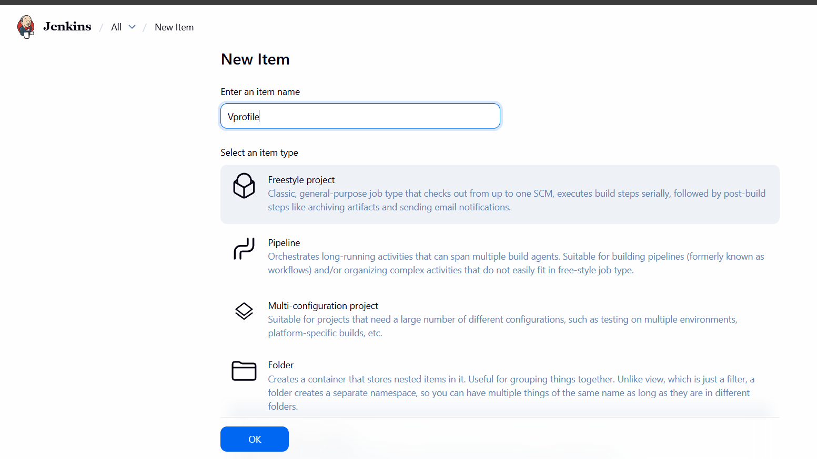
Enter the repo details and credentials not required for public repo
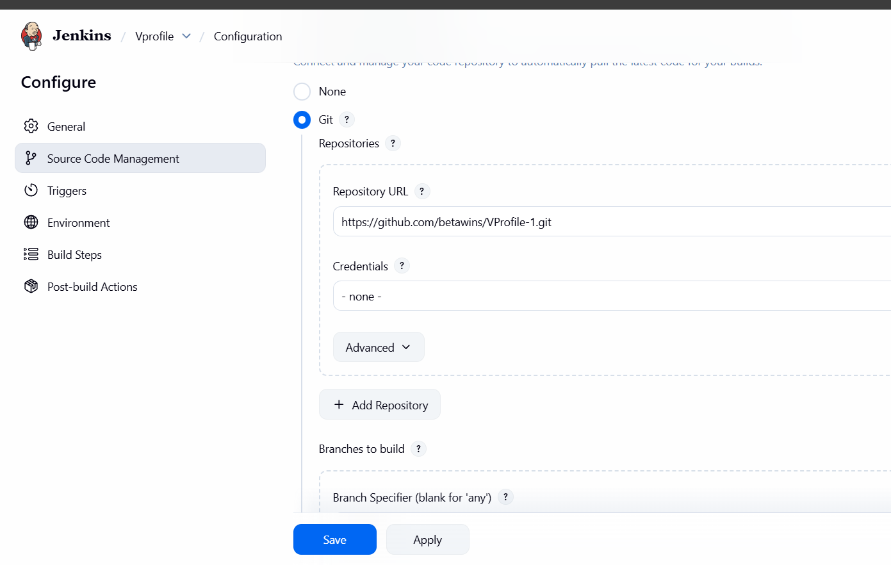

After saving you will get the job output
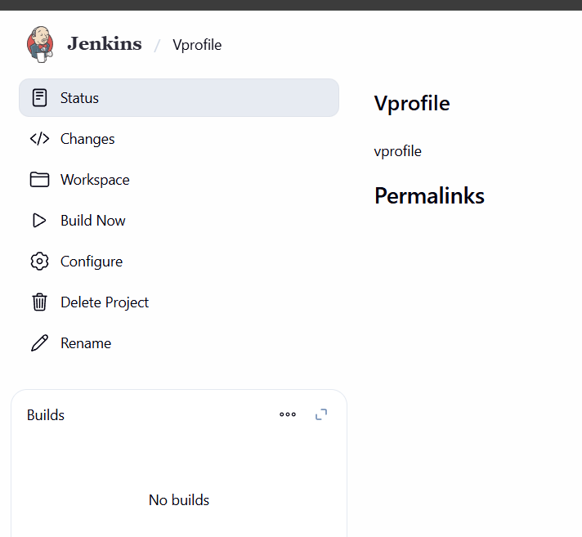
Testing the job with clicking on BUILD
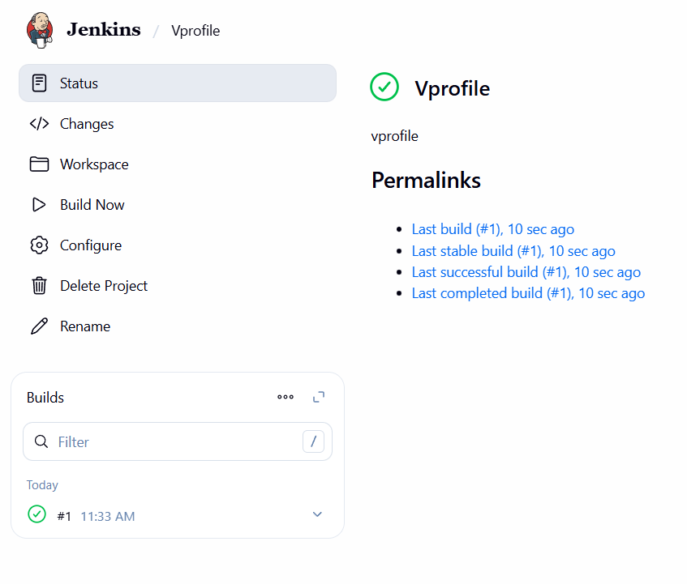
And provided the console output and it was sucess
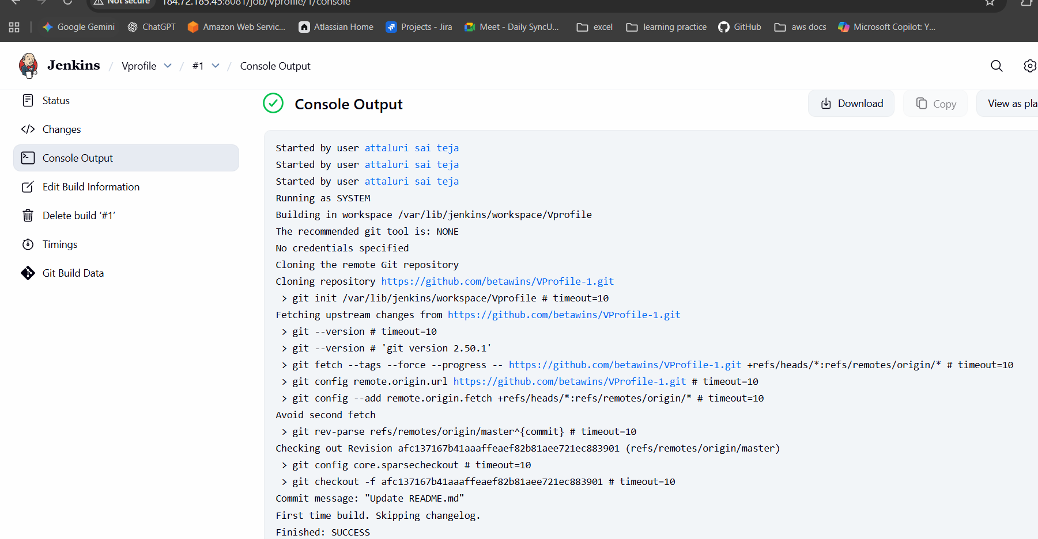
Also verified in CLI for JOB NAME
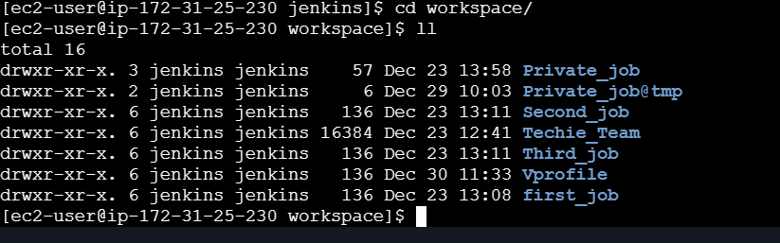

- stage2: SonarQube Integration to check the quality of code.
To integrate Sonarqube I installed DOCKER and using Docker I installed SONARQUBE
Install Docker Using yum -y install docker
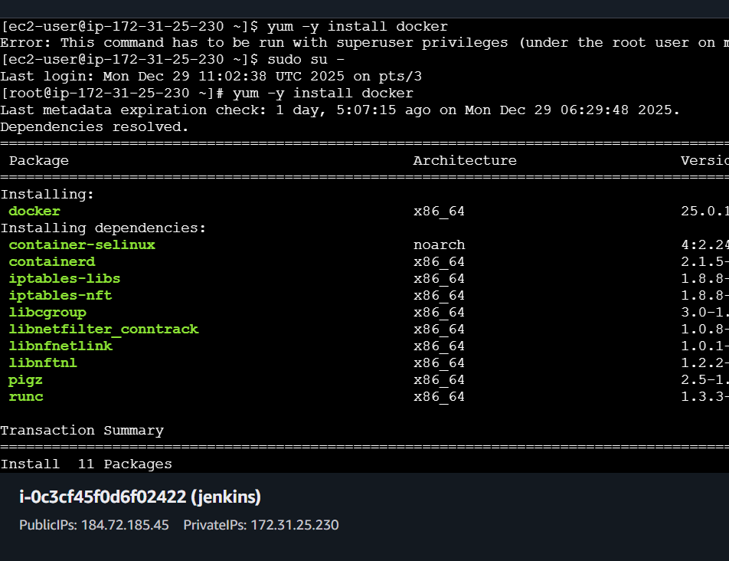
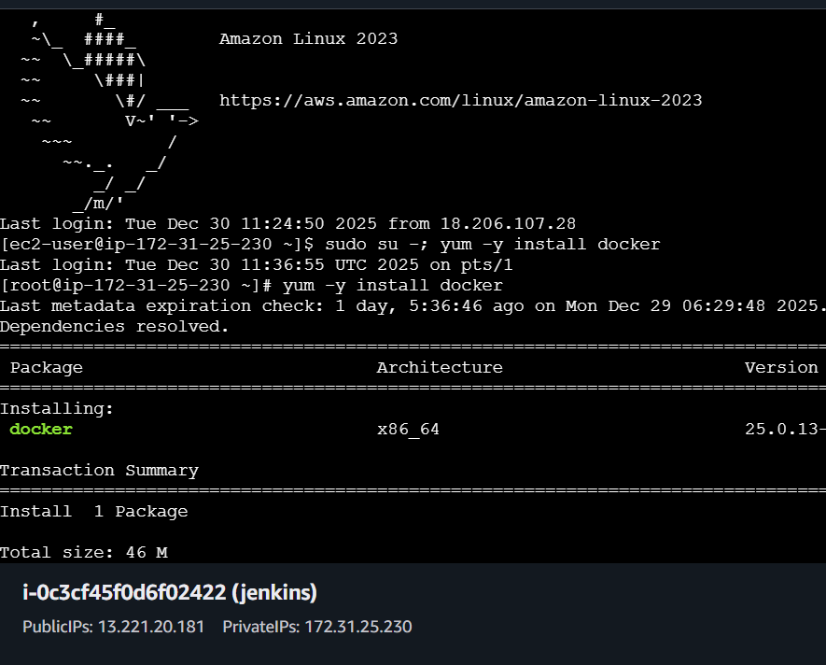
Start the docker after installation and it take some couple of seconds to install
After that execute the command docker pull sonarqube To install sonarQube
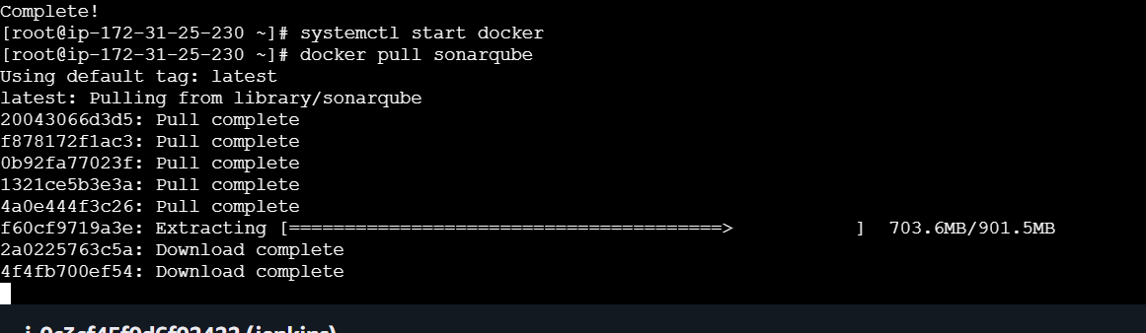
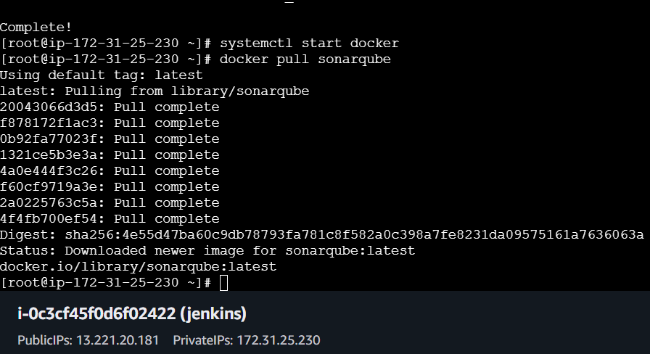
Enter the docker images to verify the installation
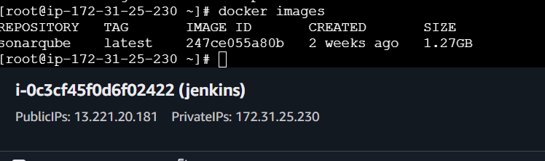

Change the port number to 9000 or 9001
Using command docker run -itd -p 9000:9001 sonarQube
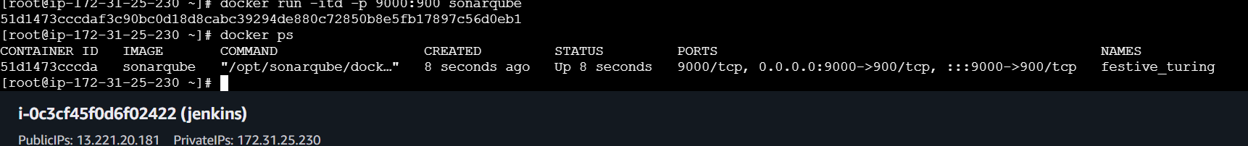
Also verify in browser and I faced a issue I mistakenly enter 900 instead of 9000..
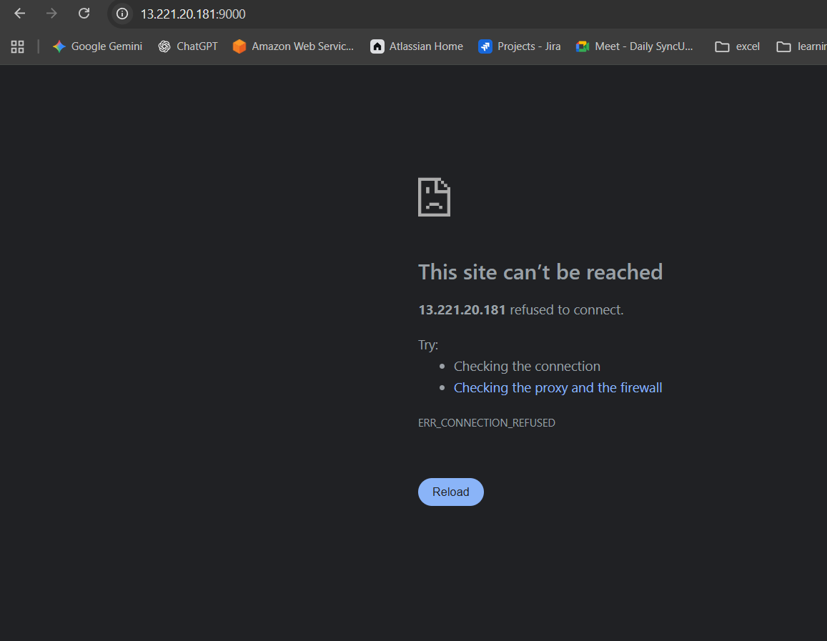
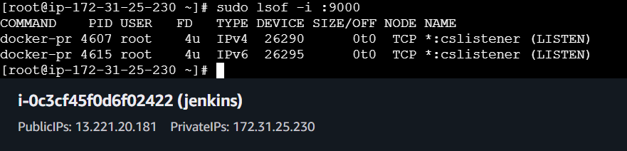

Again Changed it to 9000 and it was successfull
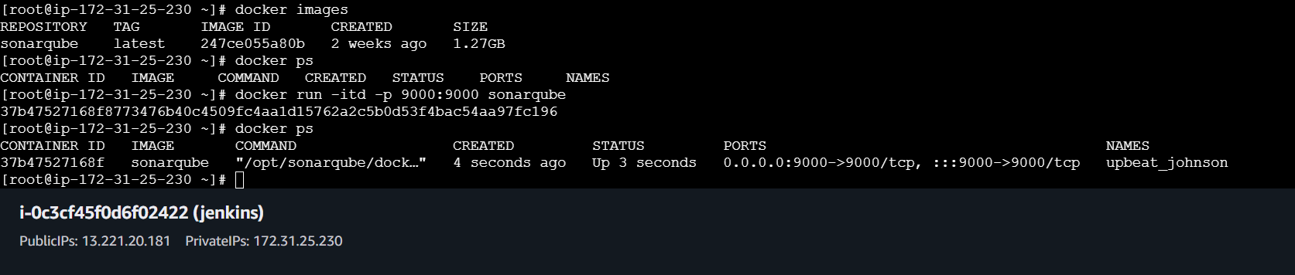
Then restart the Docker to get reflected the port number and check in website
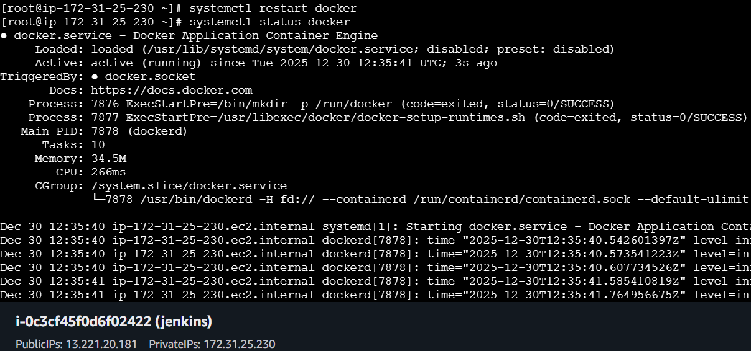
In browser enter publicip:portnumber to access the SonarQube website
Enter initial password as admin and admin
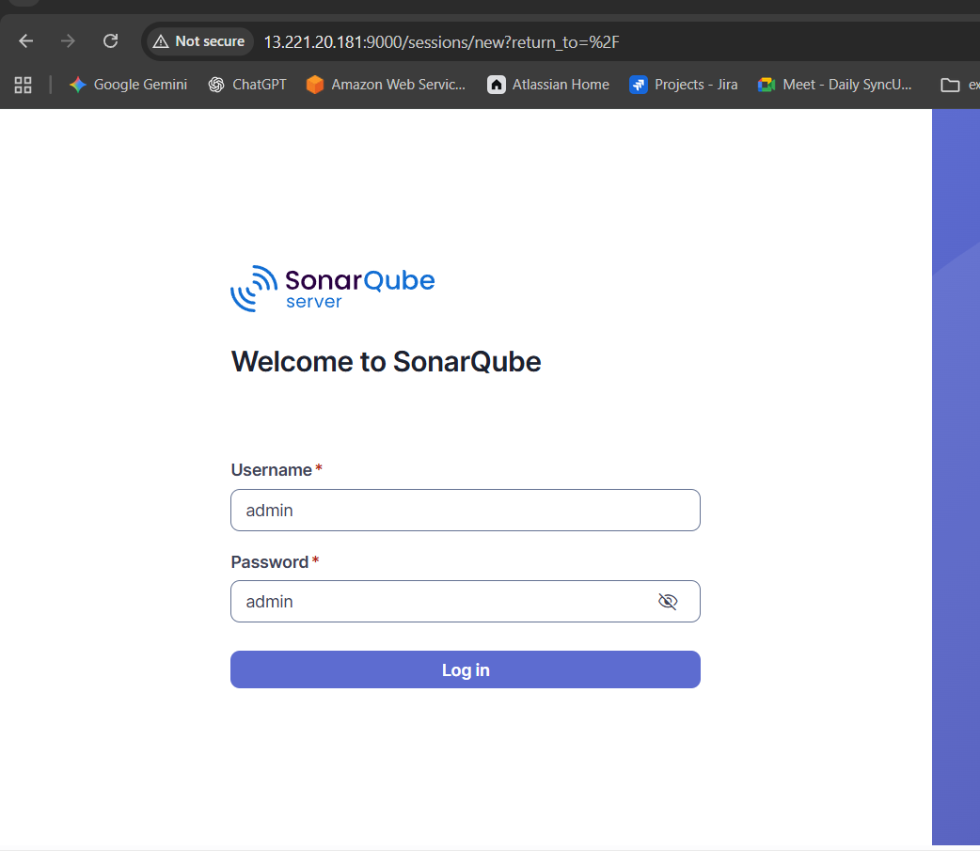
After that change the credentials and provide custom details my password is 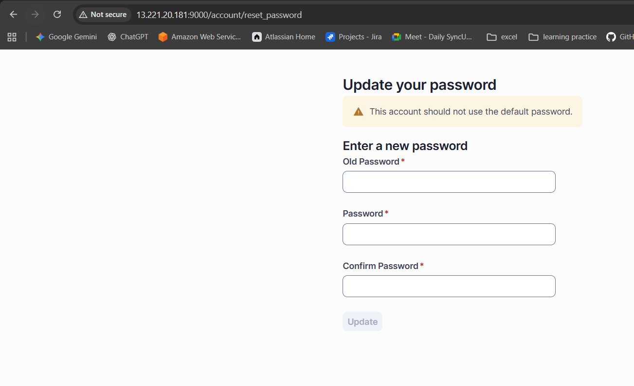
Devops@050909
And the dashboard of Sonarqube looks like the below image
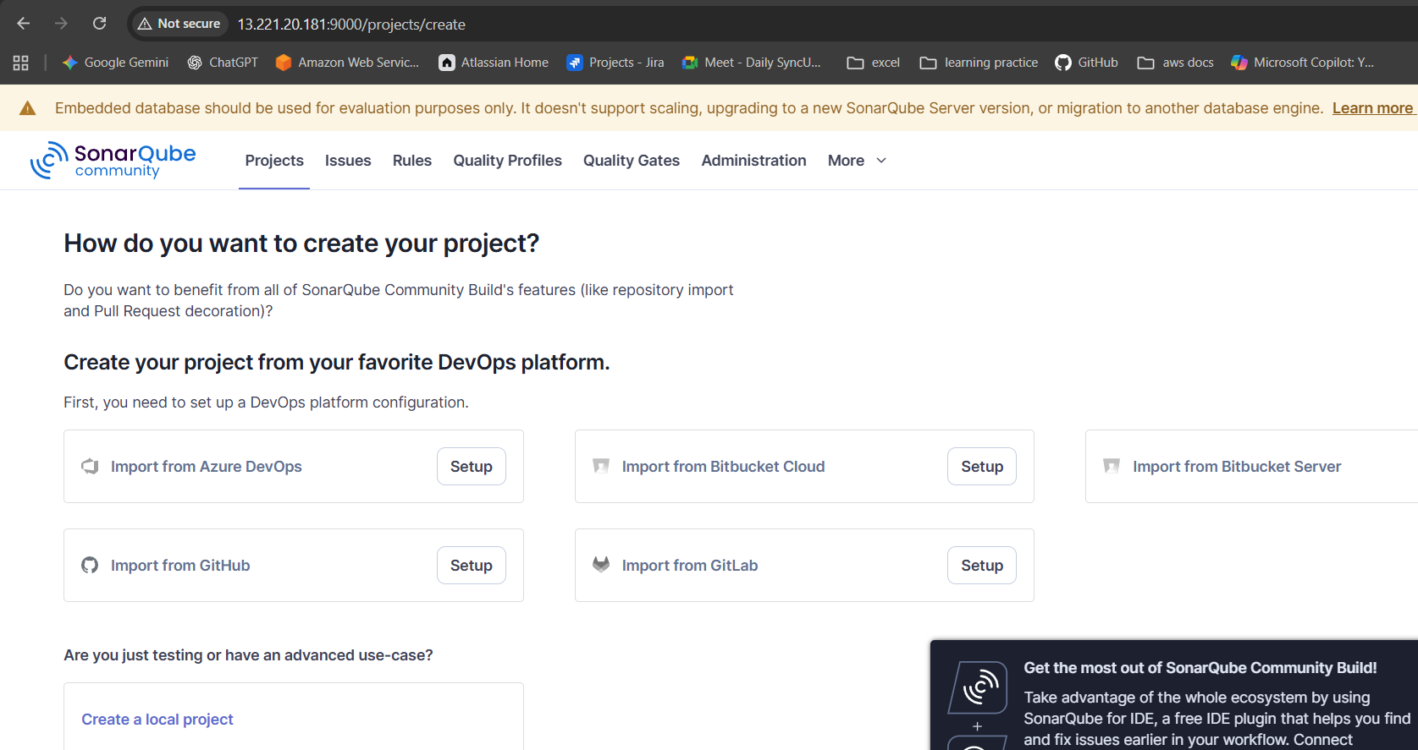

Click on The profile and and select my account and get inside of it
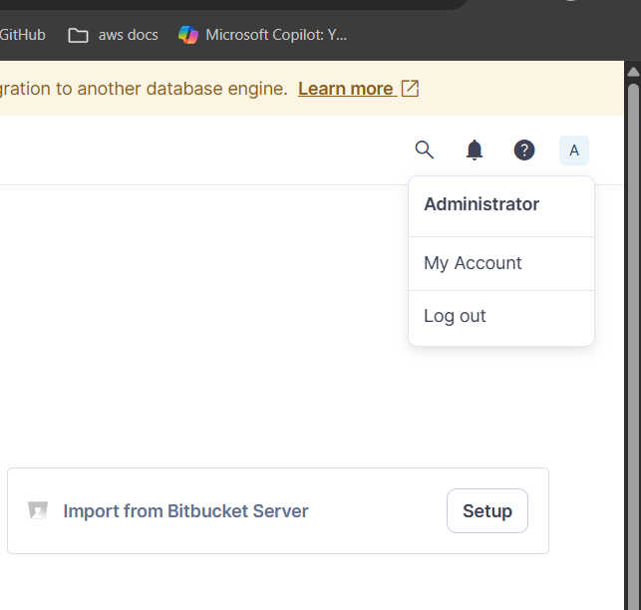
In the security section generate a token and copy the token
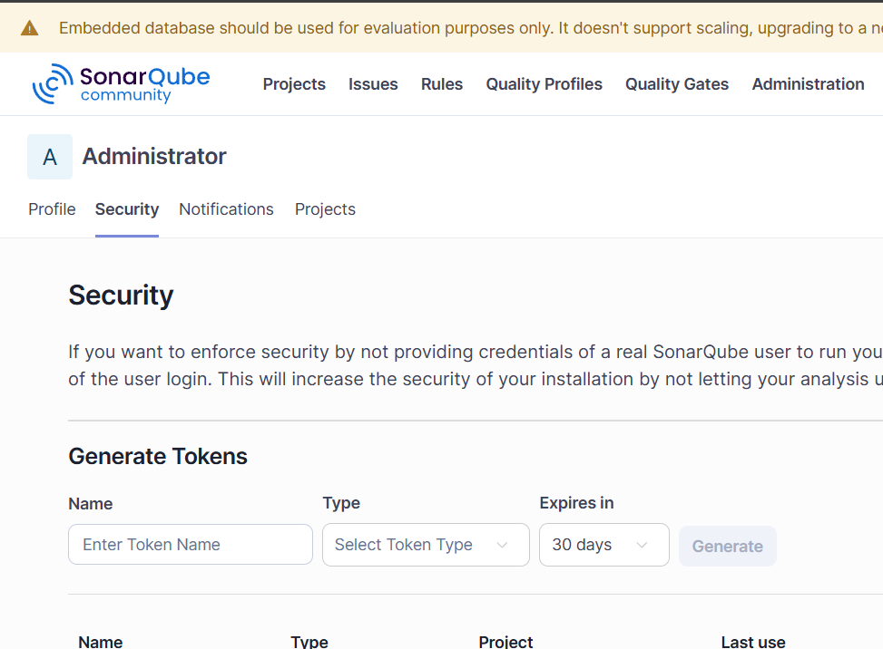
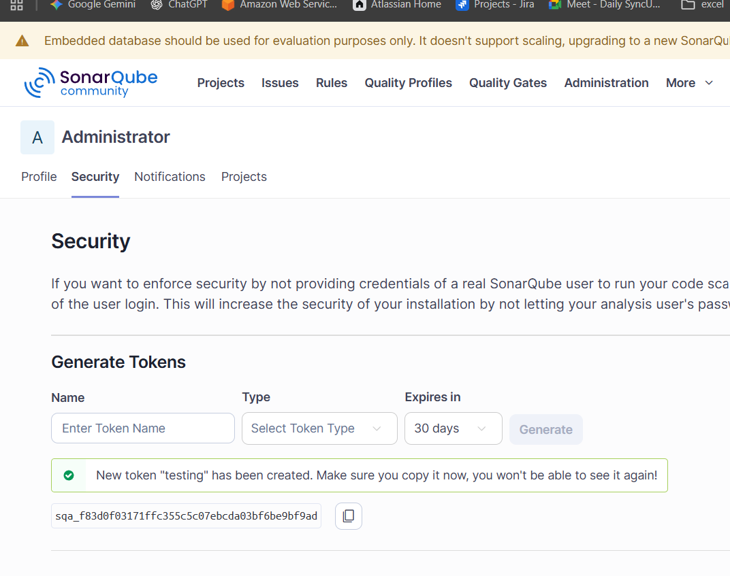
sqa_f83d0f03171ffc355c5c07ebcda03bf6be9bf9ad
Again Navigate back to Jenkins and manage Jenkins dashboard
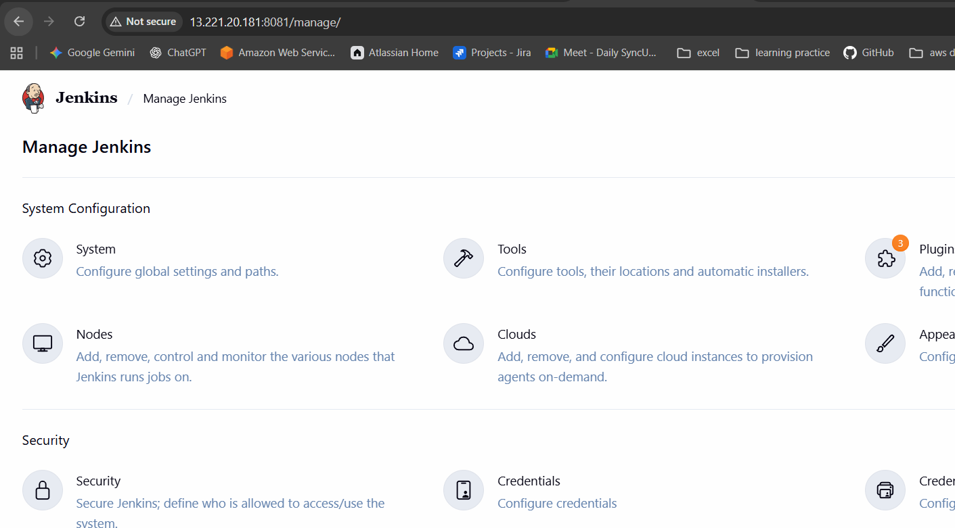

Click on Credentials >> system>> Global credentials >> add credentials
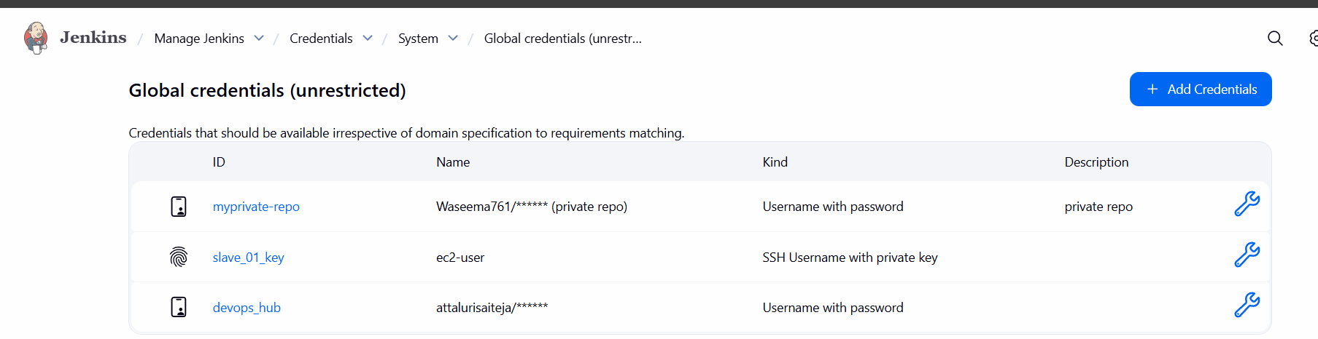
Select KIND as Secret and continue
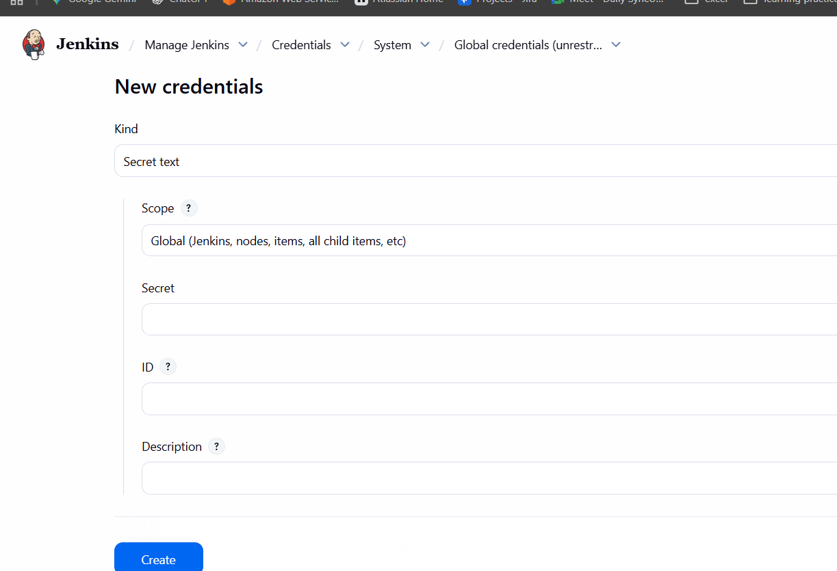

Enter the TOKEN in Secret section and continue by providing id and description to easily identify the key
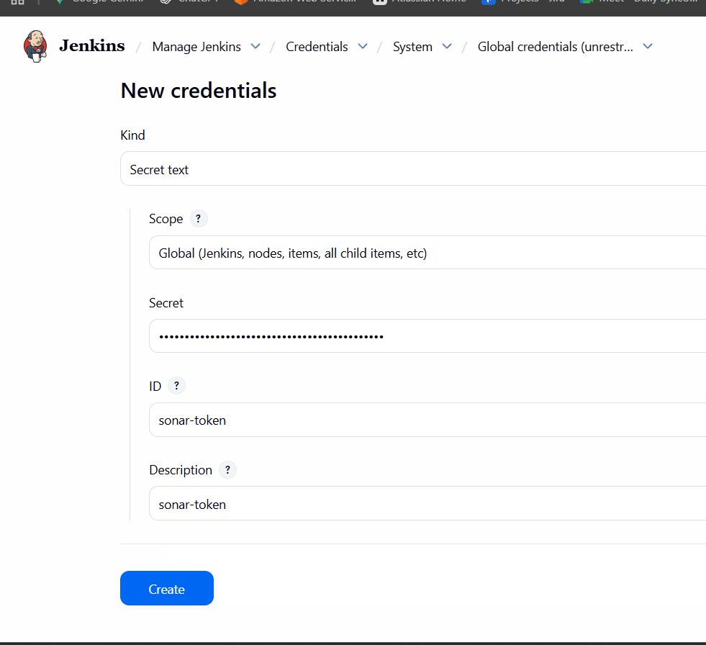
After saving that navigate to plugins and install SONARQUBE scanner plugin
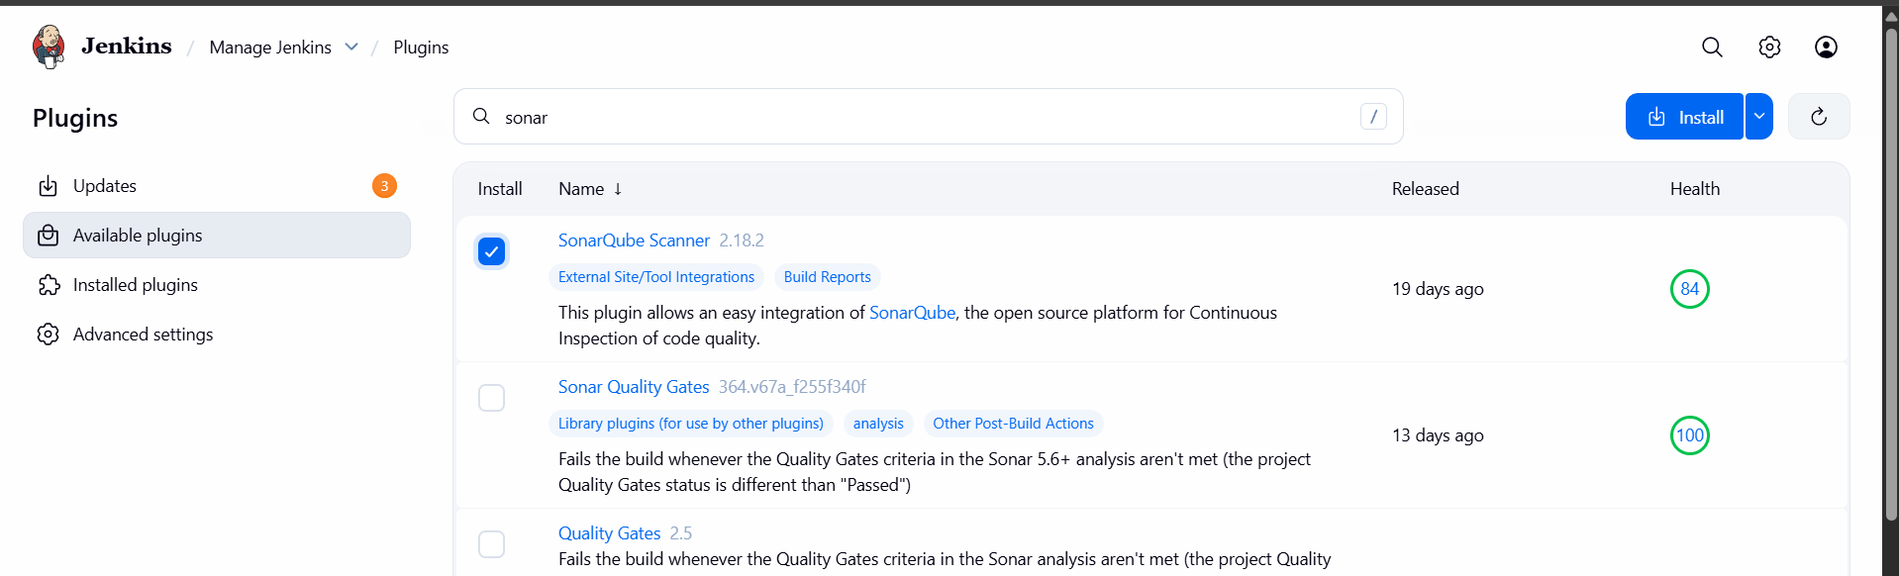

Restart the Jenkins if required
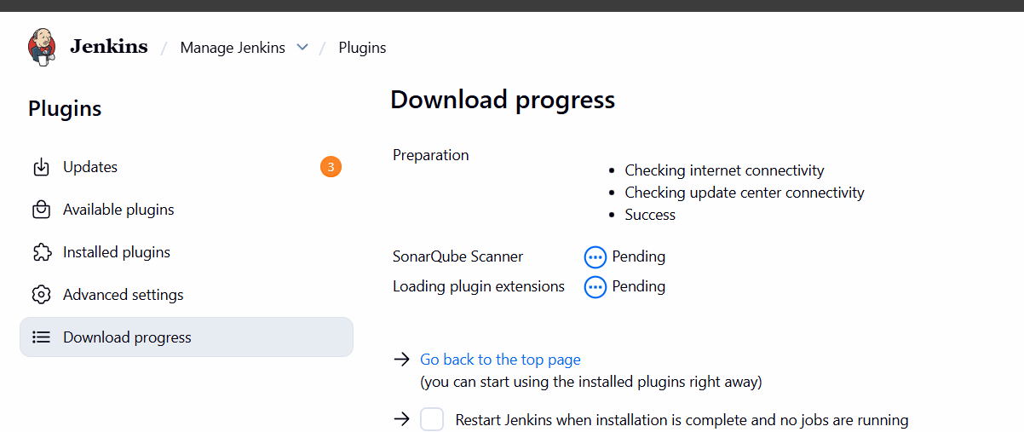
In the manage Jenkins tab select system and scroll down for SONARQUBE INSTALLATIONS tab
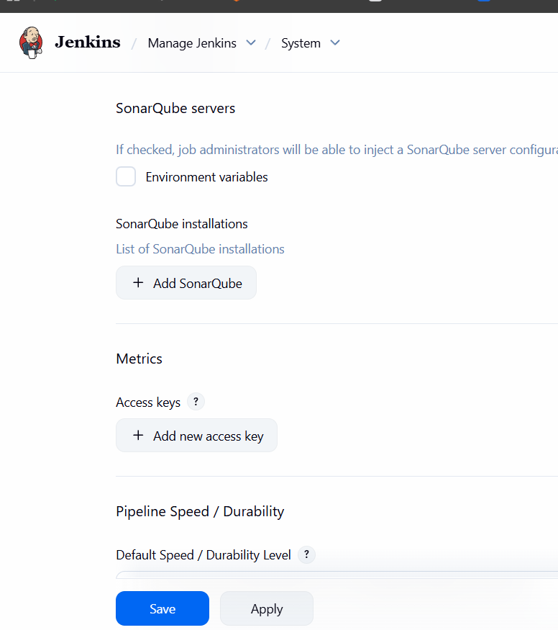

Enter the details and enter the server url of sonarqube and continue with selecting the token
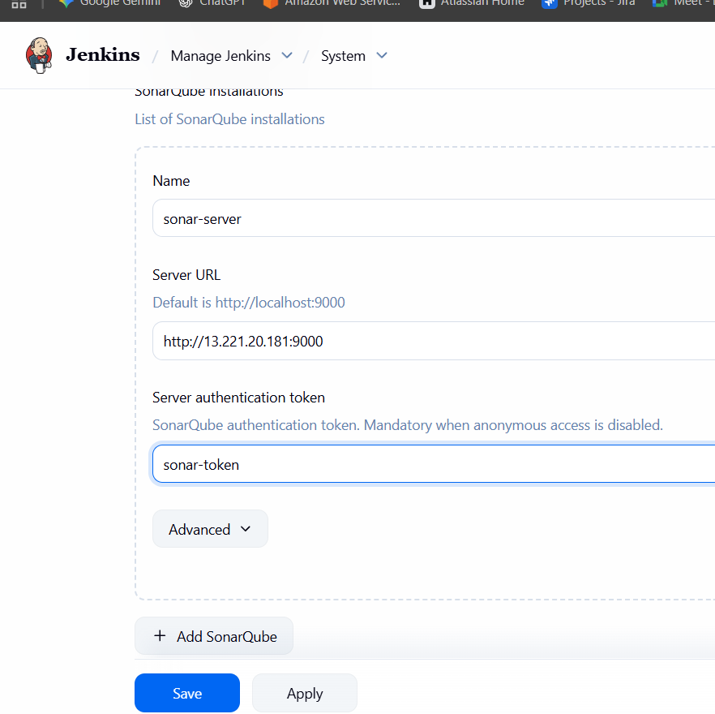

Again Navigate back to JOB and add build steps
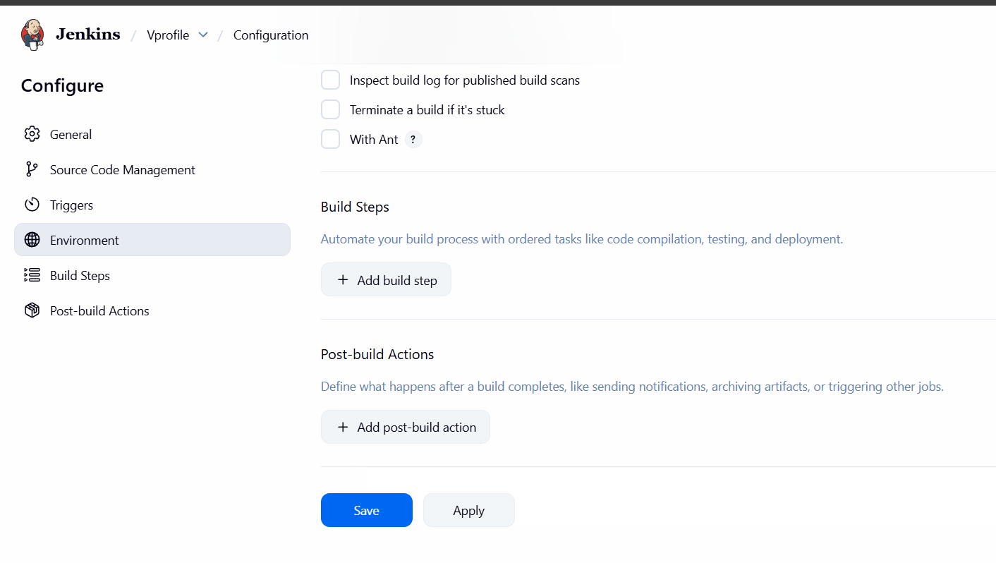
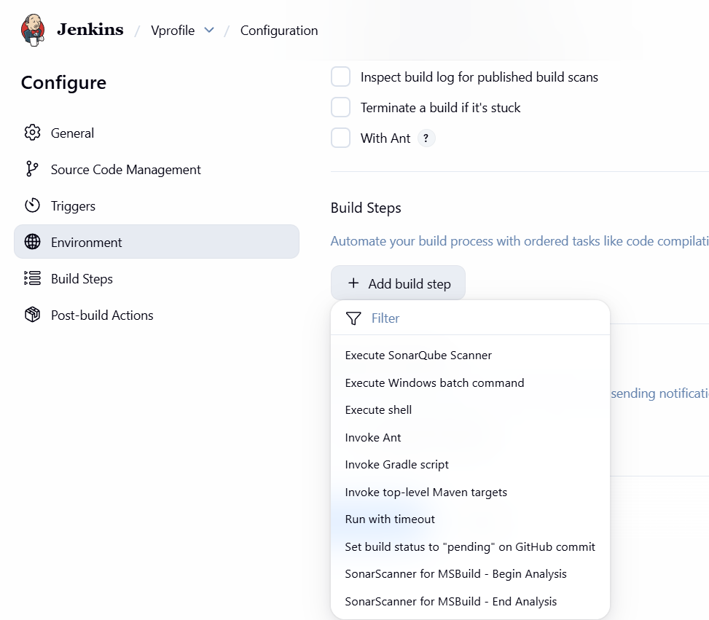
While adding it faced the error
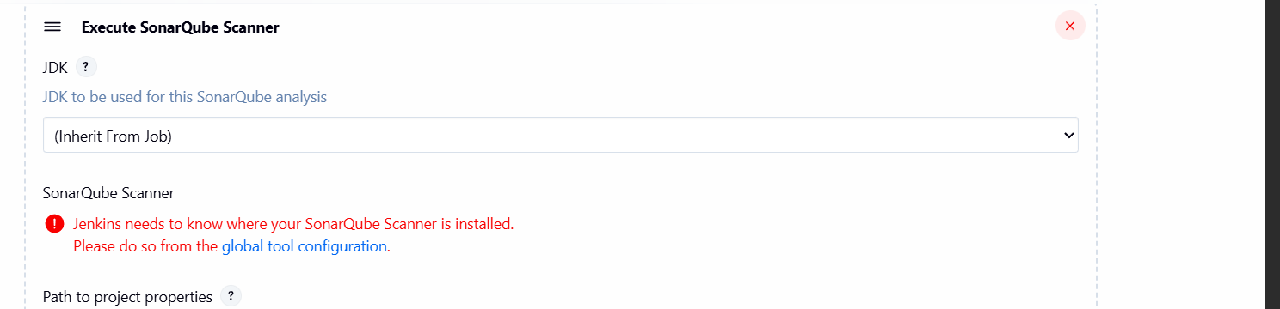
Resolvong the Errors
Executed multiple commands.
Installed sonarqube on EC2
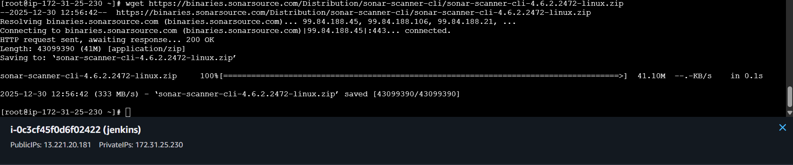
Unzip the file
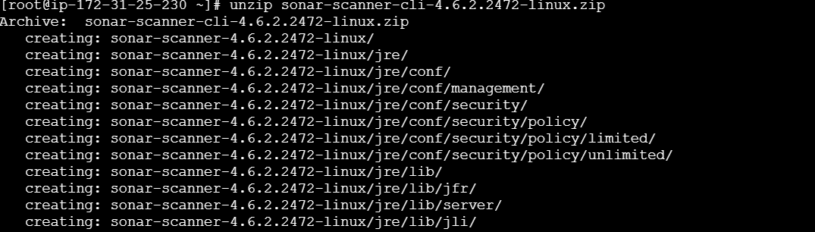
Renamed the Sonarqube
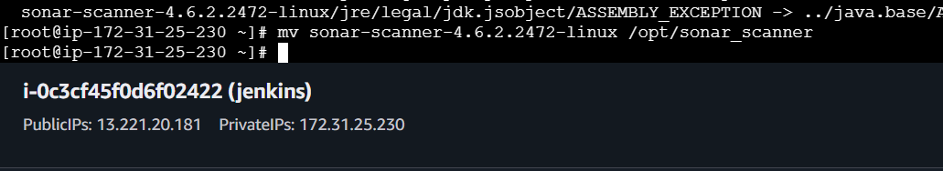

Provide the name and continue in Jenkins server in manage Jenkins server at tools section
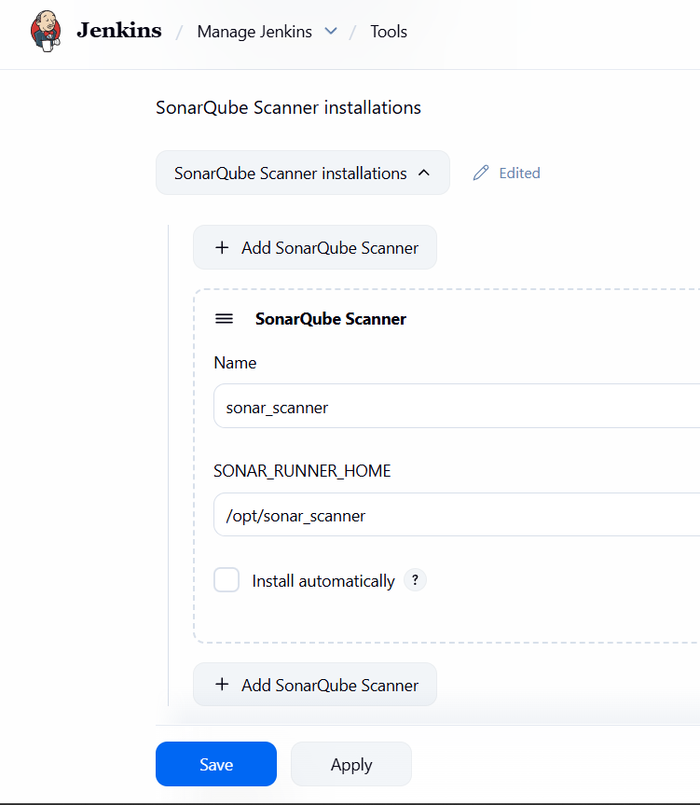

After executing the below command I successfully resolved the error
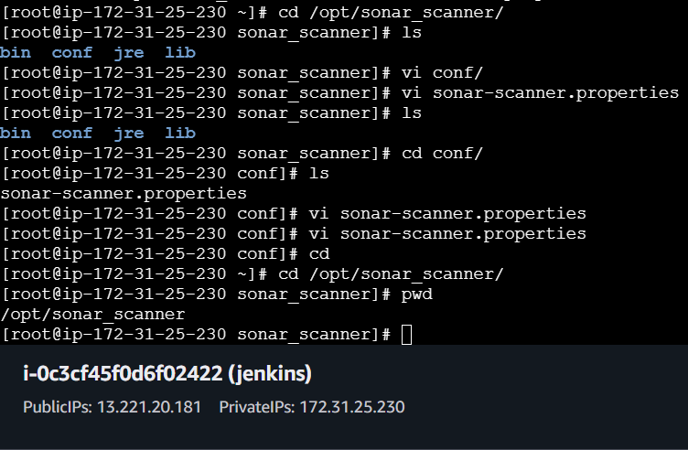
In the repo the analysis properties setails are available just copy and paste them
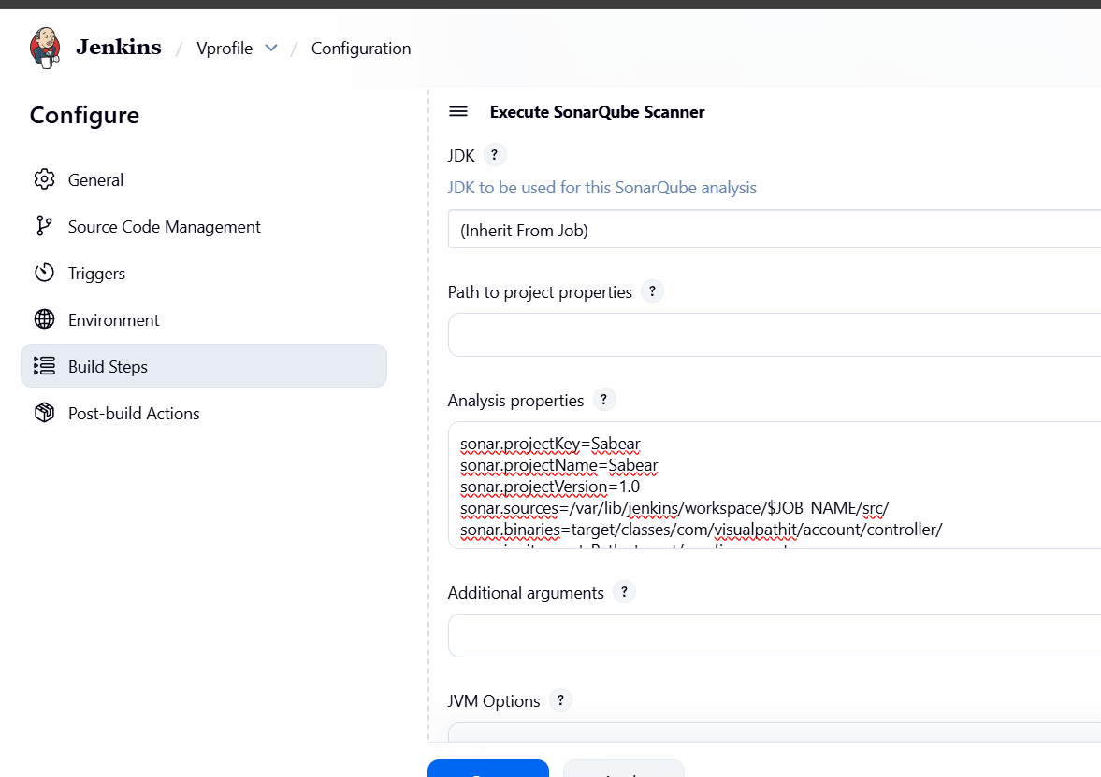
After that sonarqube integration has been successfully established
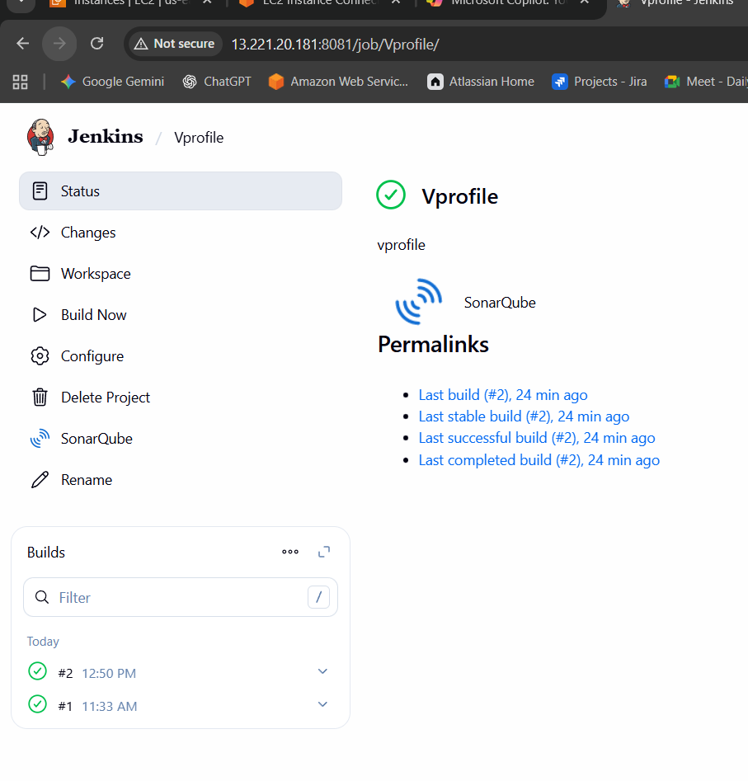

After executing the build then again faced an error the java compatability is differed
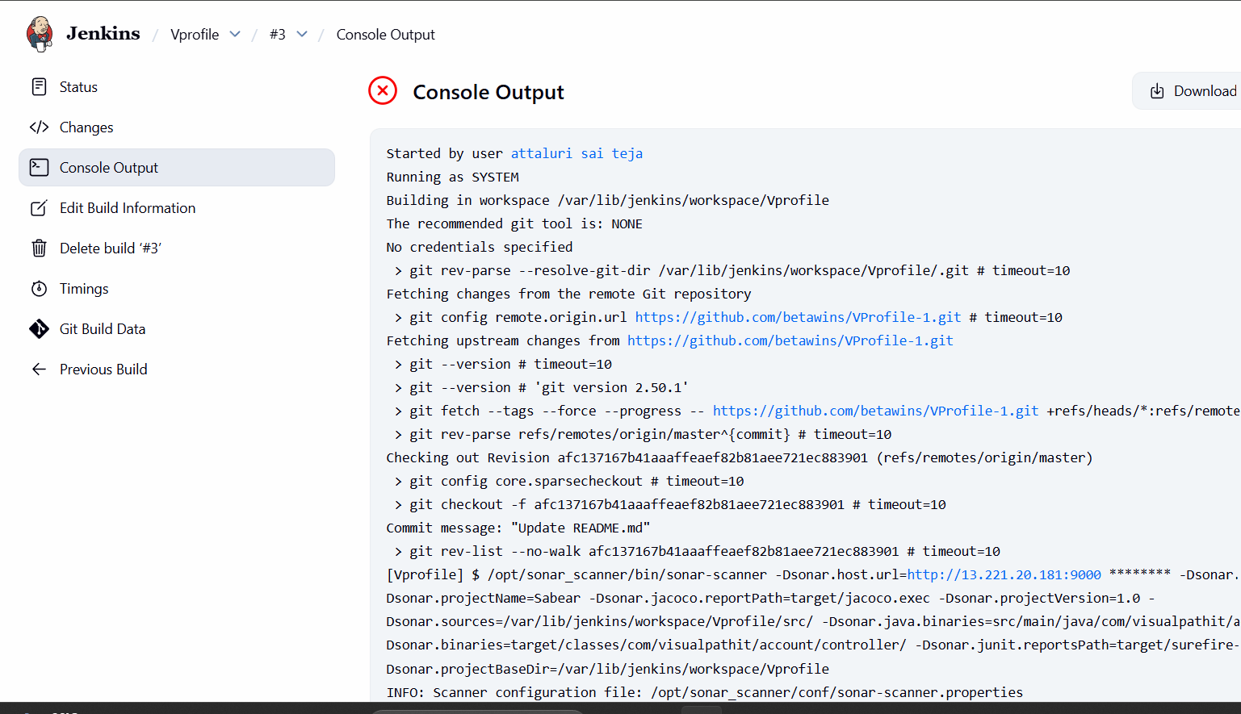
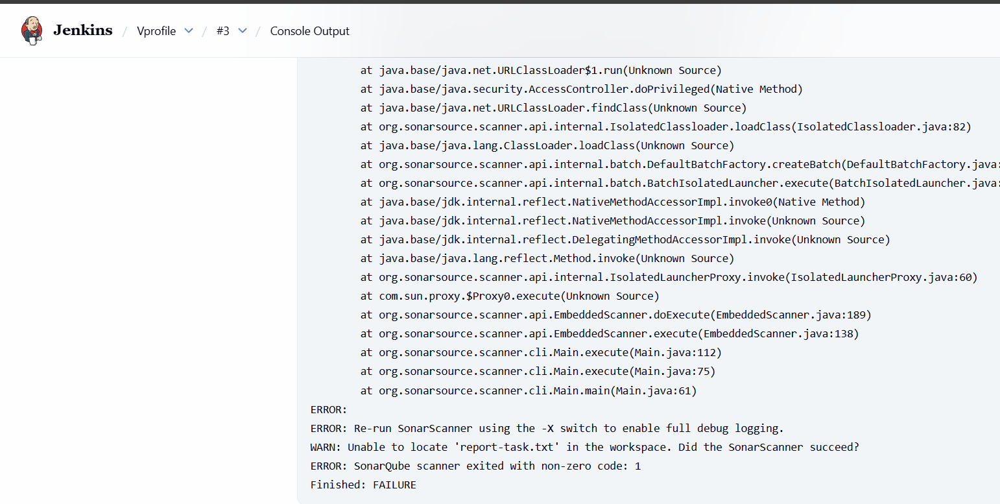

Then execute below command and resolve the issues
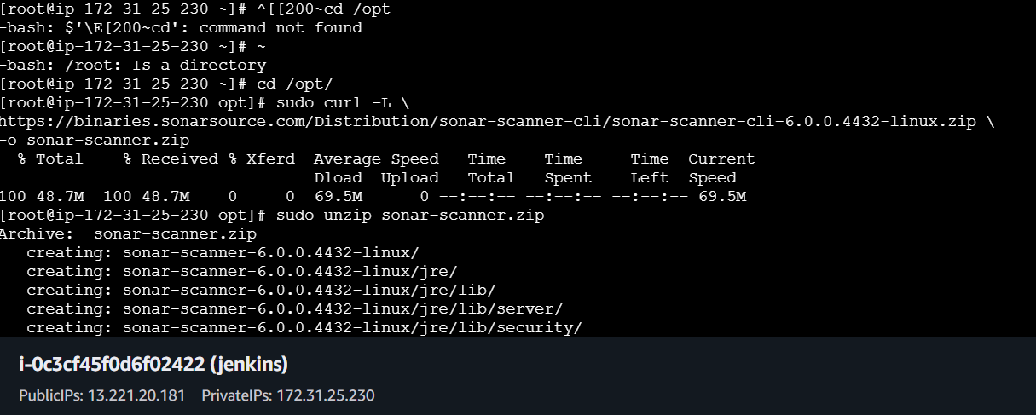
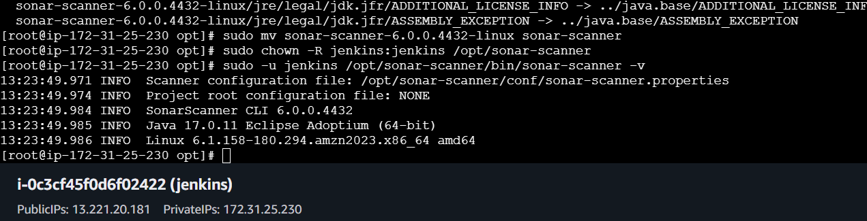
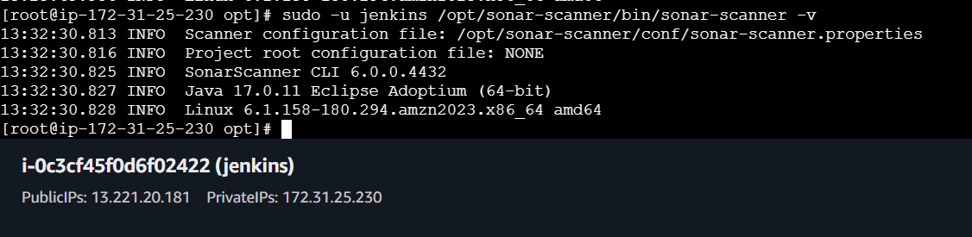

Again in the job configure add the details in execute shll by providing ip and token
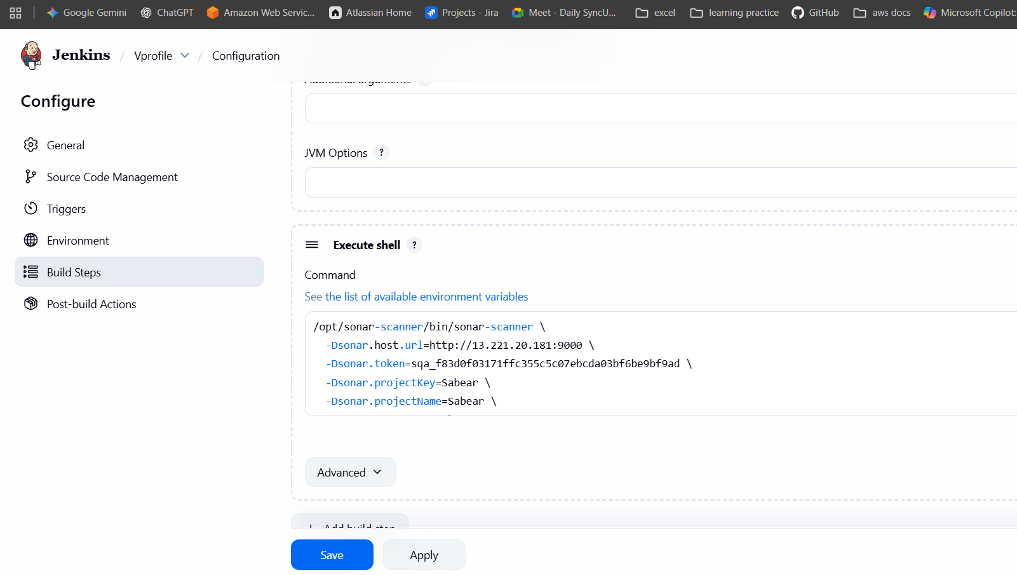
And tested using build
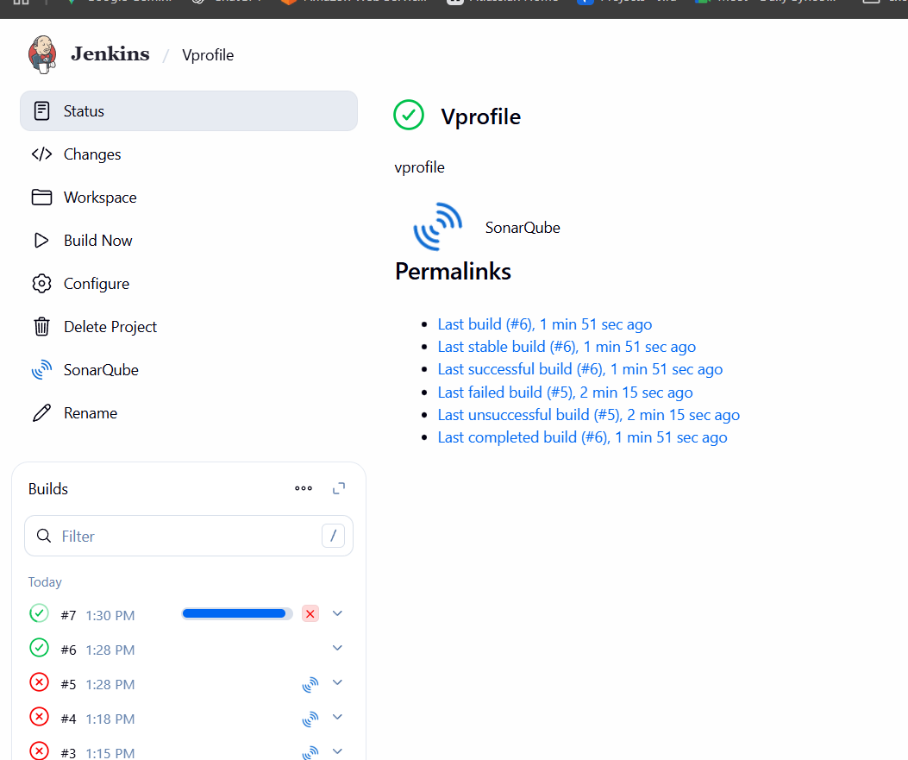
In the job dashboard the integration was successfull
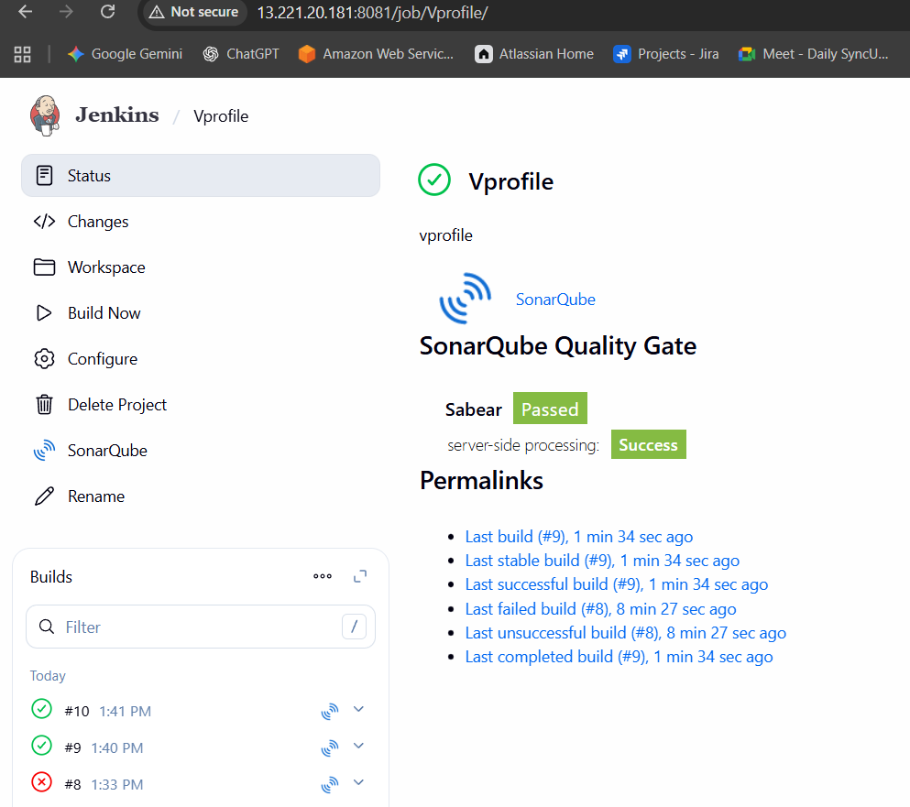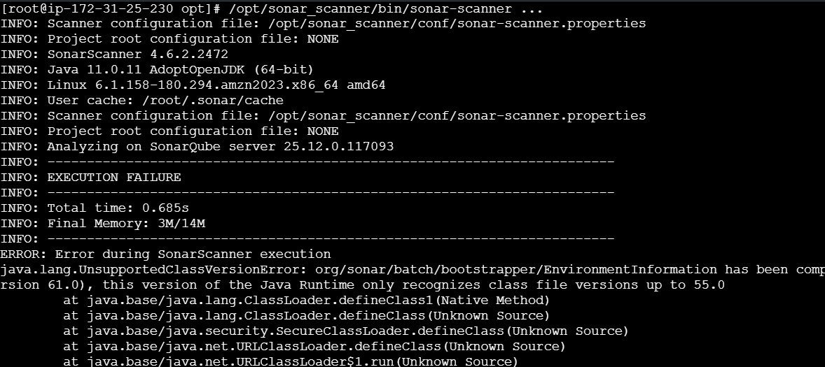
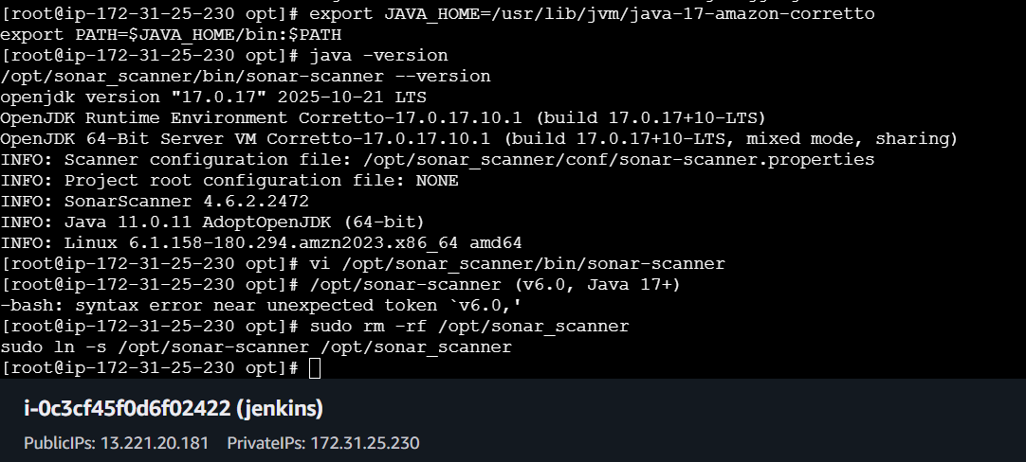
In the Sonar qube dashboard the build was able to present
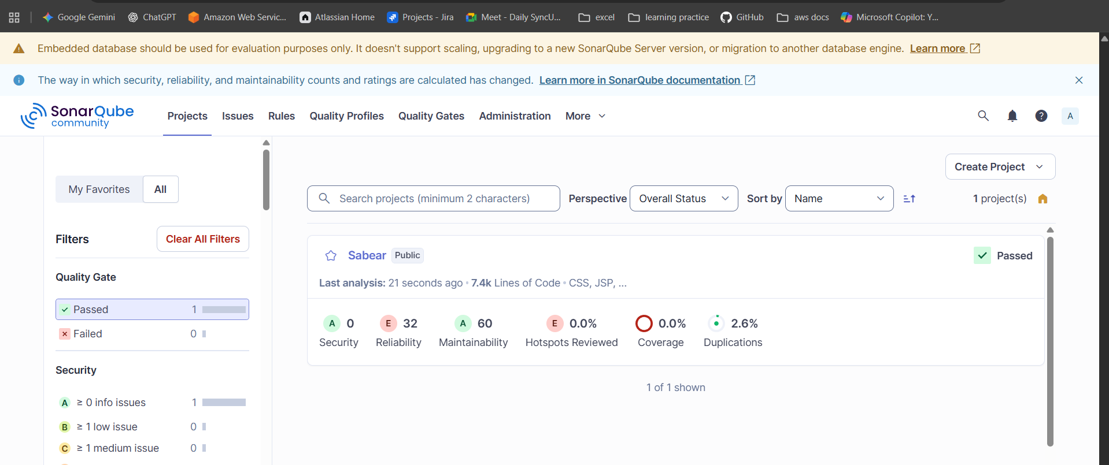

- stage3: Slack Integration to send the alerts to slack.
Install a plugin called slack notification
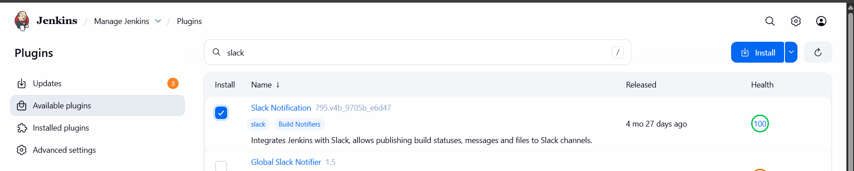
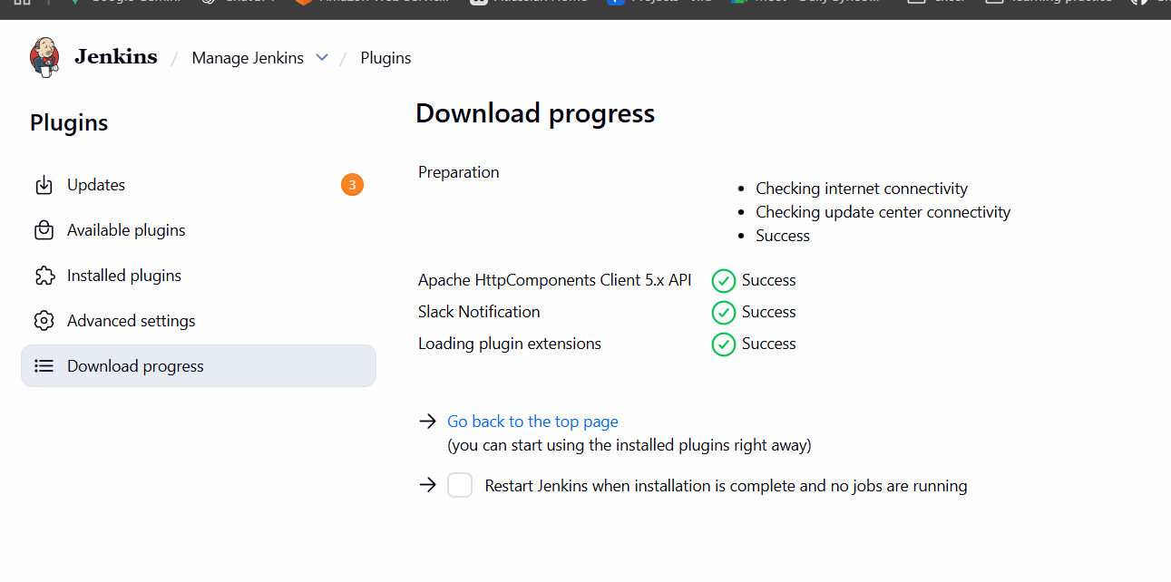
Go back to slack and click on more and select apps and click on Jenkins ci
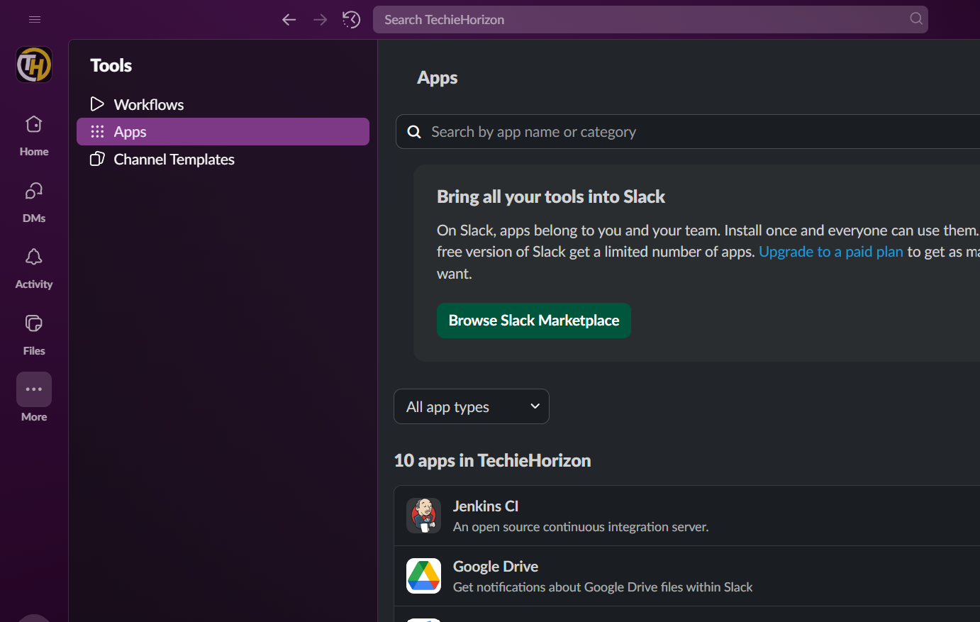
Click on the configuration
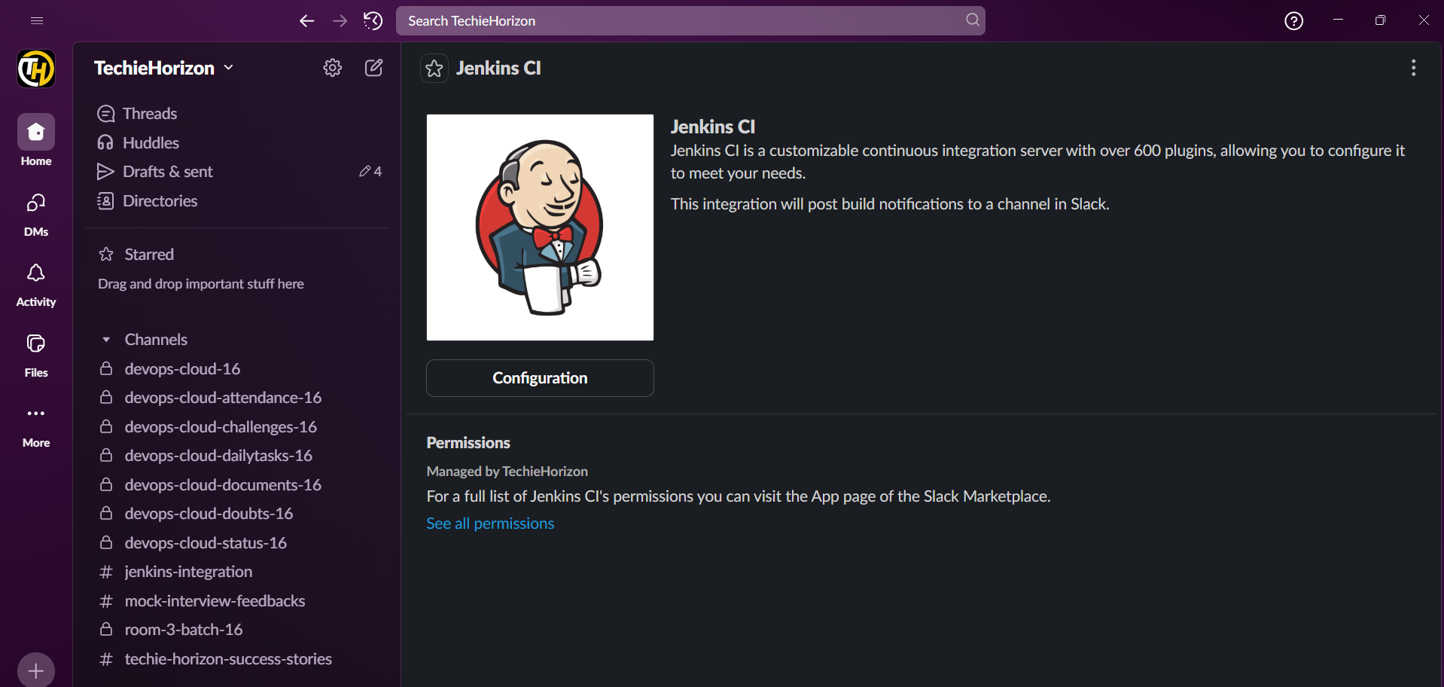
And click on add to slack and provide details
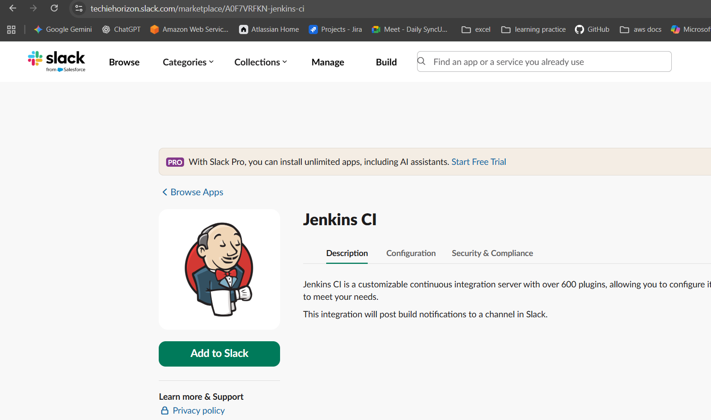
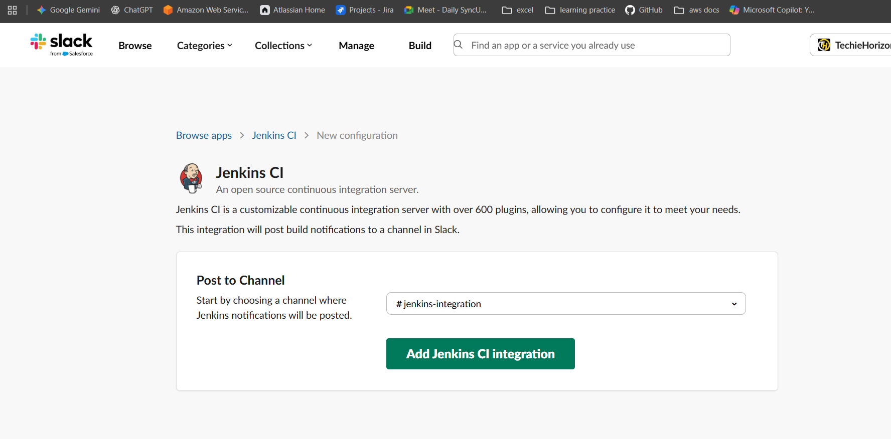
After that add credentials in Jenkins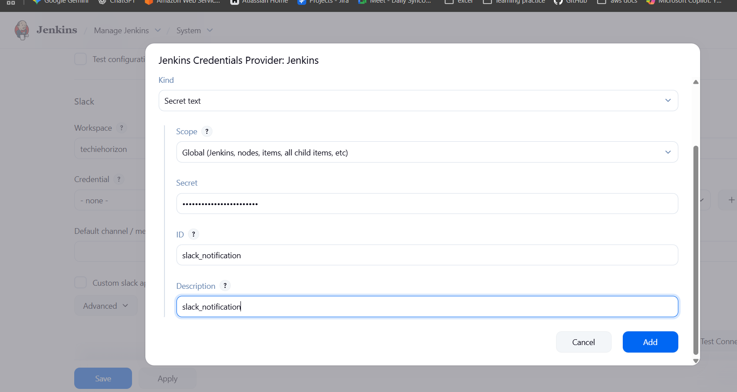

After that in the Jenkins navigate to system and add slack
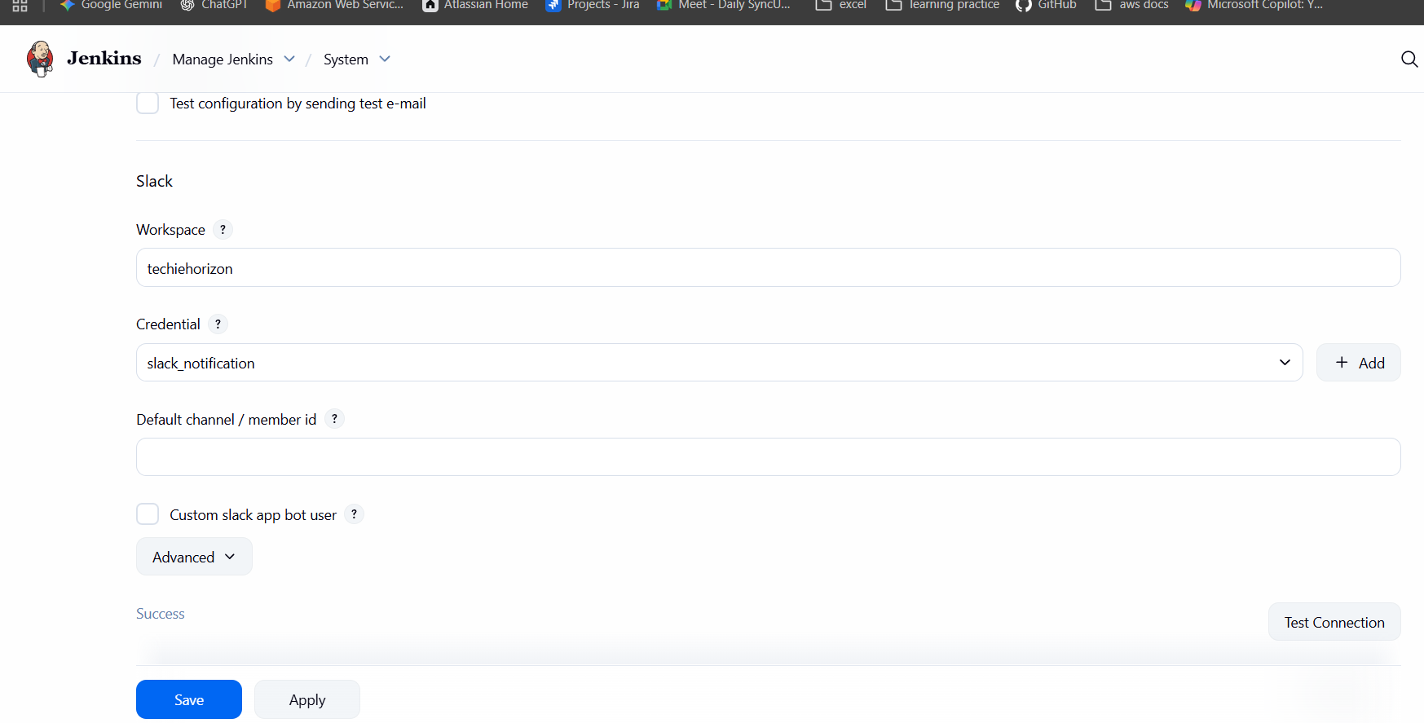
Select the post build actions which to be displayed on slack
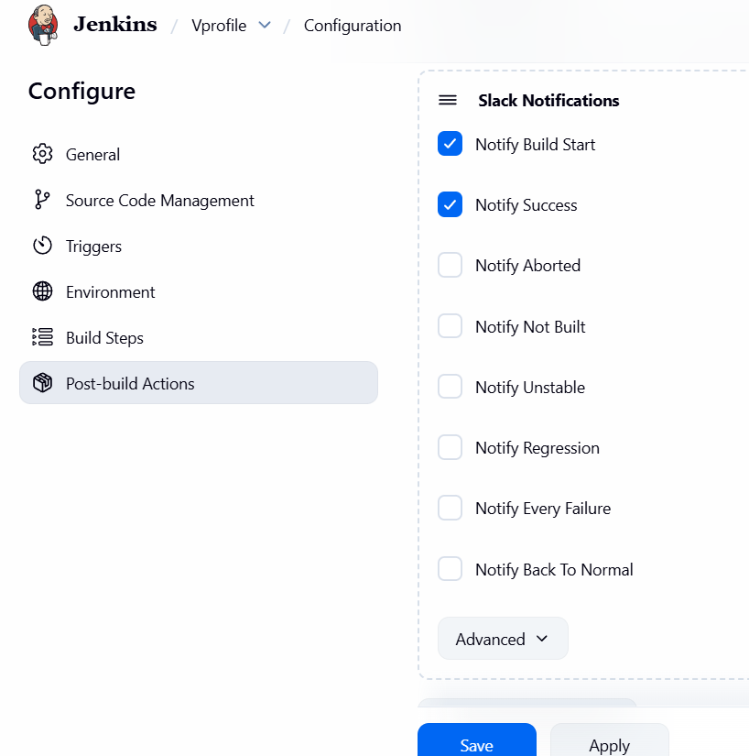
After clicking on build the status appear on Jenkins integration channel
